**Lab 11**

**Keypad interfacing (port multiplexing)**

Spring 2025

Submitted by: Mohsin Sajjad

Registration No: 22pwsce2149

Class Section: A

“On my honor, as student of University of Engineering and Technology, I have neither given nor received unauthorized assistance on this academic work.”



Student Signature: ______________

Submitted to:

Engr. Faheem Jan

Month Day, Year (25 05, 2025)

Department of Computer Systems Engineering

University of Engineering and Technology, Peshawar

**Keypad interfacing (port multiplexing)**

**TASKS:**

1. Run the program given in the lecture

**CODE:**

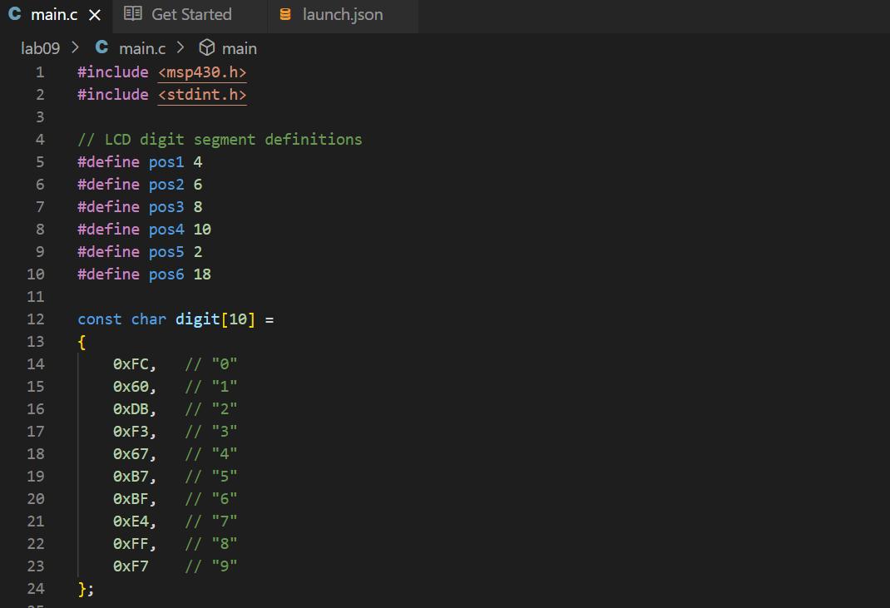

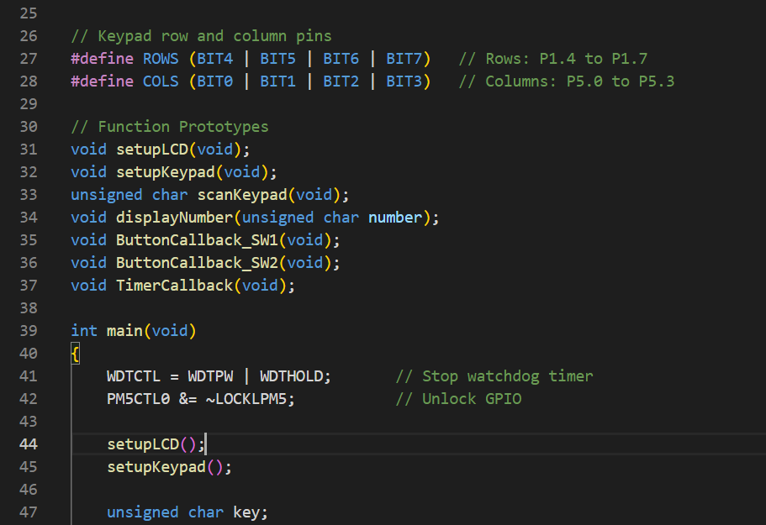

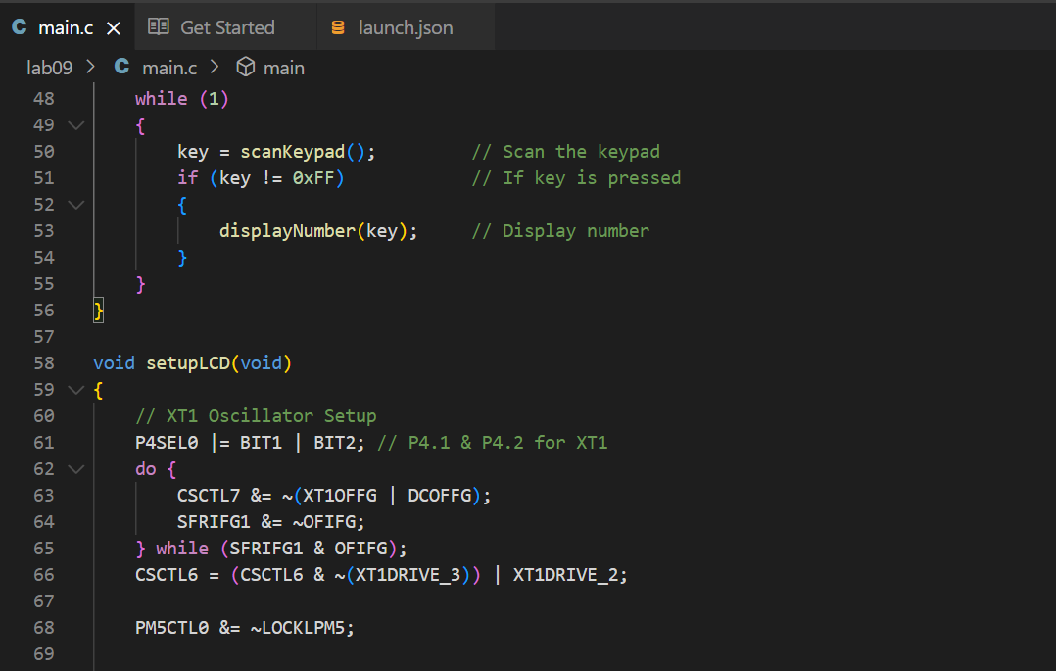

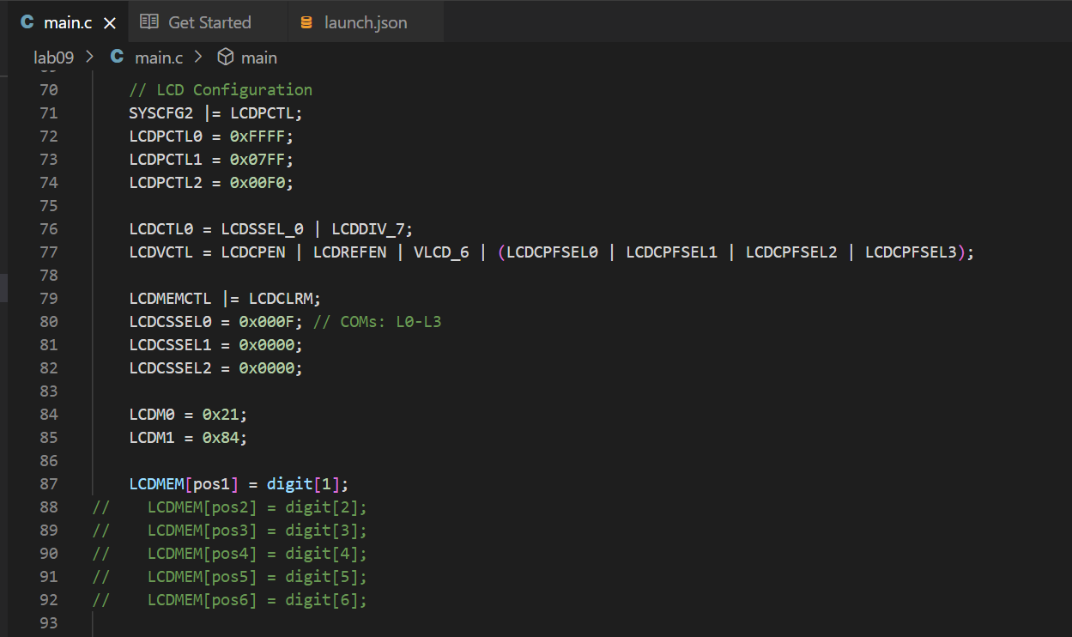

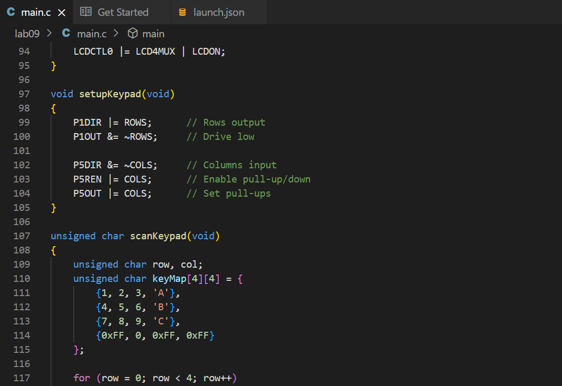

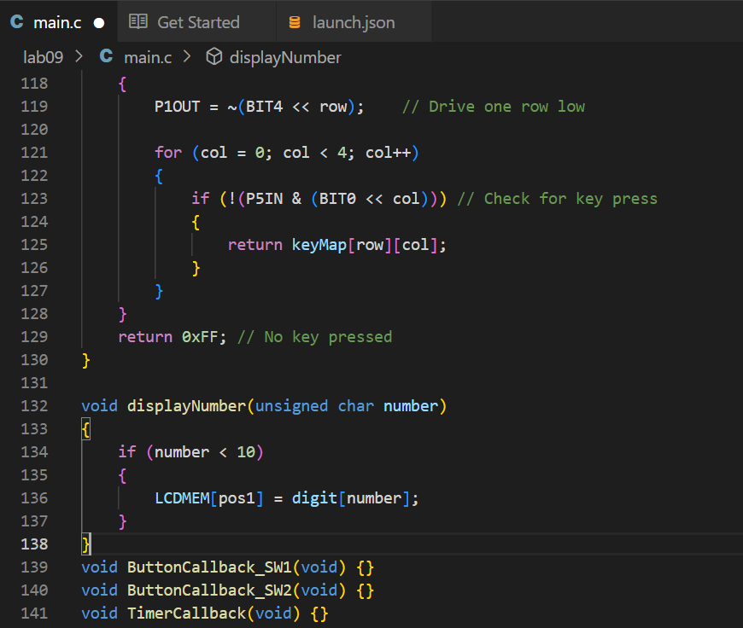

**OUTPUT:**

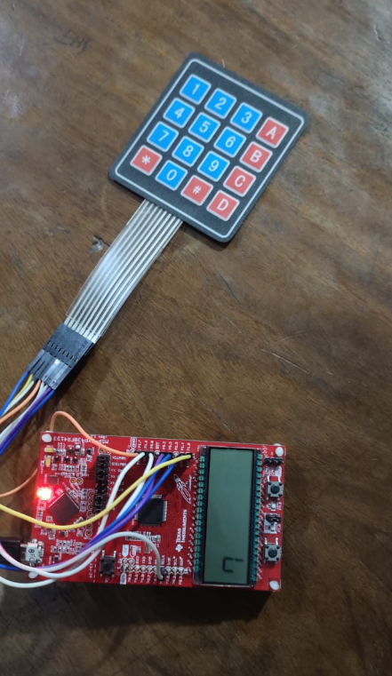

2) Display Number from to 1 to 9 on the onboard LCD (available on the Launchpad) of the MSP430Fr4133 MCU.

CODE:











**Output:  
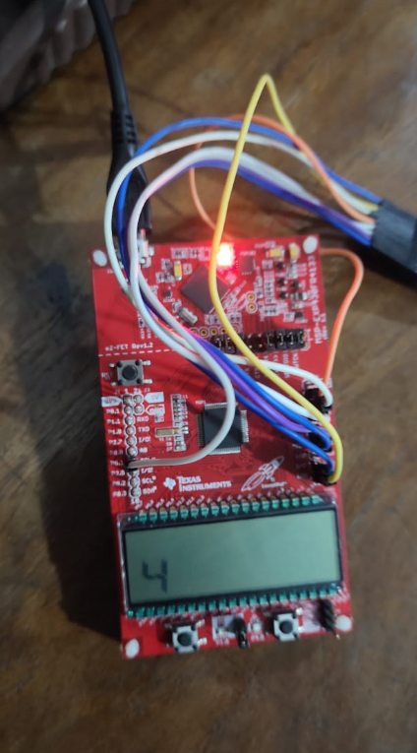**

**(Home Task)**

2) Display Numbers from 1 to 9 on the seven segment display and ON

the corresponding LED’s attached with any PORT of the MCU

Note: Attach the seven segment with P3 or any other PORT and

keypad with P1 or any other Port (you can use proteus).

**CODE:  
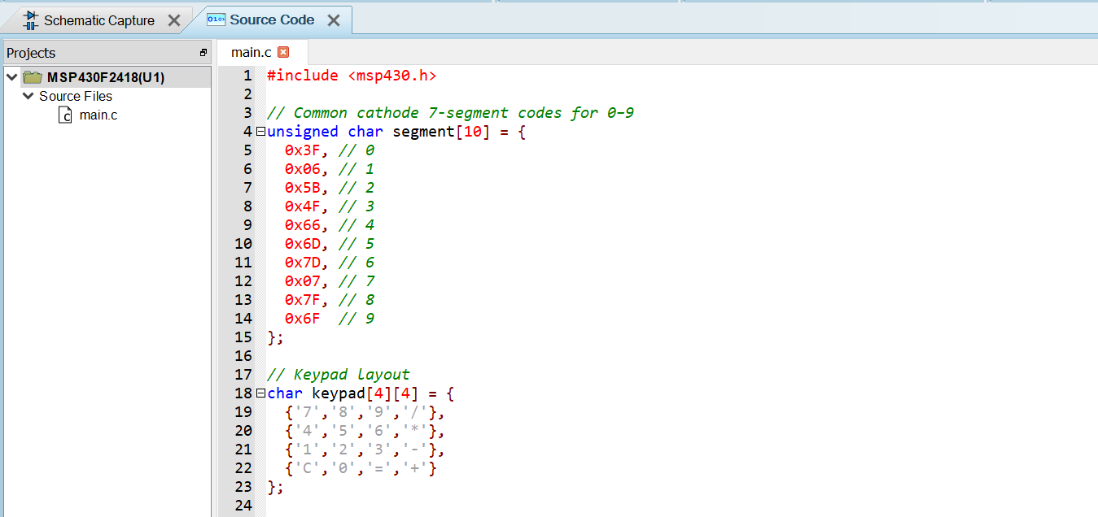**

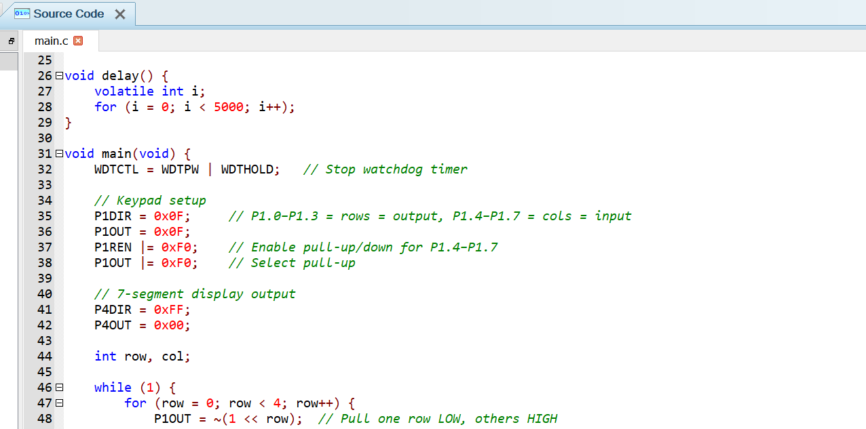

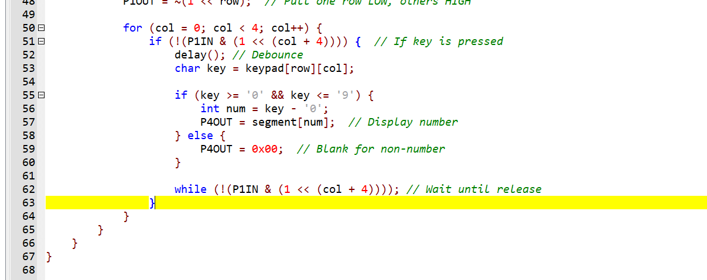

**Output:**

